Data warehouse concepts – Week 6 Lab/Lecture

Datawarehouse, is a repository used for; Storage & processing.

DW → Datamart → Cube → Dimensions → Hierarches → Measures

[4:30] Cube, Dimensions, Hierarches and Measures

* Cube: multi-dimensional perspective on things
* Dimensions have hierarches. Level of granularity of data
* Operations:

|  |  |
| --- | --- |
| Slicing | You can cut the Data warehouse on a certain criterion |
| Dicing | I phased out |
| Drilling Down | Going down the level of granularity of the data |
| Roll up | Going up the level of granularity of the data |

* Connections to the dashboard comes from the cube.
  + Connection: EDW → Cube → Dashboard

[13:00] Hierarches

* [15:30] Example; time is a dimension and year/quarter/month/day…. Is hierarchy

[20:40] Measures

* Fact table

[23:30] Visualization tools

* Looker
* Metabase
* PowerBI
* Tableau

[24:50] Data Model is part of the architecture

* Conceptional; e.g. ERD Diagram.
* Logical

PPT Start Conceptional ….

[30:00] Slide 4

* Idea behind this is to foster communication

[32:30 – 33:] Story about knowledge economy

* Moral of the story: Be hungry for knowledge 🤤

[35:20] Slide 5

[36:30] Slide 6

[37:30] Slide 7

[40:00 – 41:00] Talks a bit about how the assignment might be

[48:00] Slide 8

[49:00 – 51:30] Slide 9

[51:30] Slide 10

* Non-additive is qualitative

[53:30] Slide 11

[54:20] Slide 12

[54:48] Slide 13

* Degree of relation is what determines the type of Hierarchies

[56:10] Slide 14

* Recursive is an unbalanced hierarchy

[57:30 - ] Some explanation

[59:30 - 1:04:10] Story time about scammers

[1:04:20] Slide 18

[1:04:30] Slide 19

[1:05:40] Slide 20

* The text outside the tables in a circle is the criteria of hierarchy

[1:07:30] Slide 21

[1:10:50 - 1:11:40] Explanation about roll up

[1:11:50] Slide 22

Read about the rest of the slides and concepts, refer to the outline – Him.

[1:15:00] Slide 29

* Logical Model

PPT Logical Data Warehouse Design

[1:17:40] Slide 2

[1:23:20 – 1:24:30] His story about exams

[1:25:00] Slide 3

[1:27:10 – 1:29:00] His experience

[1:30:30] Slide 4

[1:31:10] Slide 5

Overview view of how a star and snowflake

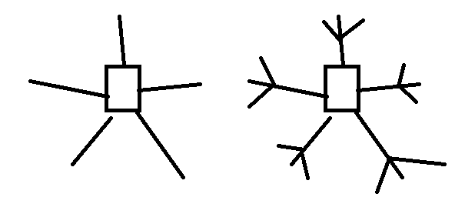

[1:33:50] Slide 6

[1:35:30] Slide 7

[1:35:00] Slide 8

[1:36:40] Slide 6

[1:37:18] About Surrogate key

[1:42:30] Slide 13

[1:43:00] Slide 14

[1:43:10] Slide 16 & 17

[1:44:10] Slide 21

Lecture end